1. **Which is not true about the arrows used in a flowchart?**

Arrows can be used to represent an input.

1. **Match the elements of a flowchart and their purpose of use in the following:**

|  |  |
| --- | --- |
| Purpose | Use |
| Calculate total of A, B, C | Process |
| Indicate that the problem has been solved. | Stop |
| Find if a number is greater than the other | Decision |
| Read a number and calculate the factorial of the number. | Loop |
| Read three numbers | Input |
| Print the total | Output |
| Indicate beginning of a problem solving flow. | Start |

1. **Complete the crossword puzzle.**

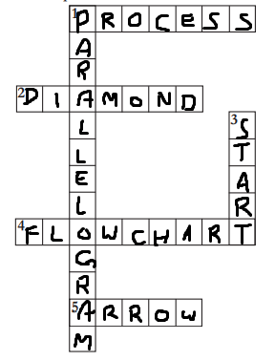

**Across**

* + 1. I am a rectangle in a flowchart. What do I represent?.
    2. When you want to show a decision making step, you can use this box.

1. You can use me to communicate ideas, graphically represent a problem solving process.
2. I connect two geometrical boxes in a flowchart.

**Down**

1. In the flowchart, I represent data or information that is available.

* 1. All flowcharts begin with me. I am elliptical in shape.
  2. **The following flowchart classifies animals as herbivore or carnivore. Lion is a meat eating animal. Elephants eat only plants. Study the flowchart and answer the questions.**

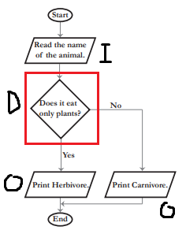

1. Indicate each element of the flowchart by putting ‘I’ for input, ‘O’ for output, ‘D’ for decision in the circles provided next to the boxes.
2. Put a rectangle around the decision structure.

Hint: See page number 89 in the lesson.

1. What is the condition which classifies an animal as carnivore?

An animal is a carnivore if it does not only eat plants

1. Write the Execution steps if the input is a Lion.

Read “Lion” -> Does it eat only plants? (No) -> Print “Carnivore”

1. What is the condition which classifies an animal as herbivore?

An animal is a herbivore if it eats only plants

1. Write the execution steps if the input is an elephant.

Read “Elephant” -> Does it eat only plants? (Yes) -> Print “Herbivore”

**5. A, B, C are the marks scored by a student in Science, Mathematics and English. Refer the flowchart and answer the questions.**

**Start**

**Read A, B, C**

**Sum A + B + C**

**Average = Sum/3**

**Print Average**

**End**

II

a.

b.

* 1. Sweta, who scores 60 marks in Science, 70 marks in mathematics and 75 marks in English. Use the adjacent flowchart and provide the execution steps in calculating the average marks of Sweta. The first step is given.

60, 70, 75

Sum = 60 + 70 + 75 = 205

Average = 205 / 3 = 68.333333

Print 68.333333

* 1. A student whose average marks is above 75 is awarded a star. Fill in the following phrases in the flowchart for finding if a student gets a star or not.

Yes

Is average greater than  
 75

Yes

No

No

Award a star

Do better to get a star

Award a star

Do better to get a star  
Is average greater than 75

* 1. Is Sweta awarded a star? No
  2. Marks of two more students are given below. Study it and fill in the blanks with the average marks of each student and whether the student is awarded a star or not.

|  |  |  |  |
| --- | --- | --- | --- |
|  | Science | Mathematics | English |
| Riya | 75 | 80 | 72 |
| Suman | 72 | 70 | 82 |

1. Riya’s average is 75.666667. So she is awarded a star.
2. Suman’s average is 74.666667. So she is not awarded a star.

e. The three main steps in the given flowchart are:

i. Read marks of three students. ii. Calculate average

iii. Check if average above 75 (and award star if true)

1. **The following empty flowchart gives the steps to be followed while seeking admission to new school. The phrases to be filled in the boxes are also given. Complete the flowchart by filling in the number of the correponding phrase, inside each box. For example: the number corresponding to the first box in the flowchart is 7.**
2. 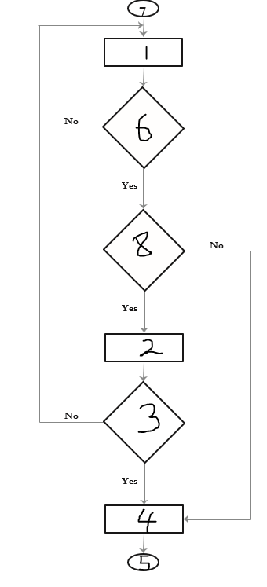Search for a school
3. Prepare for the admission test and write the test.
4. Did you pass the exam?
5. Submit necessary documents and get admission.
6. End
7. Are seats available?
8. Start
9. Is there an admission test?
10. **The following flowchart gives the steps followed while taking attendance in a class. Three arrows and a loop are missing. Complete the flowchart as follows:**
    * + Draw the three missing arrows and loop at the correct place.
      + Label the decision arrows with yes or no.

